Software Requirement Specifications
<Mental Health Tracker>



Submitted by
SAWERA SHAHZADI (F24BINFT7M04031)
Submitted to
Dr. Muhammad Asadullah

Department of Information Technology
Faculty of Computing
The Islamia University of Bahawalpur

Meeting Details
Sr No | Details | Date | Supervisor Signature
Summary
The Mental Health Tracker is a digital application designed to help users monitor and improve their emotional well-being. The system allows users to record their daily mood, write personal journal entries, receive self-care reminders, and access mental health resources. It also generates useful insights and visual reports based on user data to help individuals understand their mental health patterns over time.
This SRS document describes all the functional and non-functional requirements needed to design, develop, and maintain the Mental Health Tracker application. The goal is to provide a clear and detailed guide for developers, testers, and project stakeholders.

Table of Contents
1. Introduction 4
1.1. Purpose 4
1.2. Scope 4
1.3. Product Perspective 4
1.4. User Characteristics 4
1.5. Similar apps and systems/Literature Review 4
1.6. Proposed Technologies 4
2. Requirements 5
2.1. Function Requirements 5
2.1.1. Sign Up 5
2.2. Non-Functional Requirements 5
3. Use Cases and Flow of Processes 6
3.1. Use Case 1 7
4. References 8

- Introduction
The Mental Health Tracker System is designed to help individuals monitor, understand, and improve their emotional well-being through daily mood logging, symptom tracking, and personalized insights. In today’s fast-paced environment, many people experience stress, anxiety, depression, and other mental health challenges but lack a structured way to track their emotional patterns or seek timely support. This system provides a digital platform that makes mental health monitoring simple, accessible, and data-driven.
The application allows users to record their moods, track symptoms, view trends over time, receive reminders, and access helpful recommendations. By analyzing user-generated data, the system helps individuals identify emotional triggers, recognize improvements or declines, and take informed steps toward better mental well-being. It also provides a supportive environment for self-reflection, early detection of mental health concerns, and better communication with healthcare professionals if needed.

  - Purpose
The purpose of this SRS is to define and document the complete set of requirements for the Mental Health Tracker system. The SRS provides detail for developers, testers, and stakeholders to accurately design and implement a system that helps users monitor and improve their mental well-being through mood logging, tracking symptoms, viewing trends, and receiving helpful reminders.
  - Scope
The Mental Health Tracker is a cross-platform application that allows users to:
- Create an account and securely log in
- Record daily mood, symptoms, notes, and activities
- View history in list or calendar form
- View analytics such as mood trends, averages, and frequency of symptoms
- Receive reminders for journaling
- Export or delete their personal data
The project will be implemented using HTML (frontend), Python (API/backend), and C++ (optional desktop module and secure local storage).

  - Product Perspective
The system is a standalone application with optional desktop and web versions.
It is composed of:
- Frontend (HTML/JavaScript) for user interaction
- Backend API (Python) for business logic, authentication, mood tracking, and analytics
- C++ Module for secure encrypted local storage and high-performance features in the desktop version
It interacts with a database and notification services

  - User Characteristics
- General Users: Individuals aged 13+, basic mobile/PC literacy, seeking to monitor mental health.
- Health Enthusiasts: Users tracking wellness metrics regularly.
- Students or professionals facing stress, wanting mood logs and reminders.
- Admins (limited): Manage system performance and backend configurations (no access to personal data).
No special technical skills are required for end-users.

  - Similar apps and systems/Literature Review
Existing apps that inspired this system:
- Daylio – mood tracking with statistics and journaling.
- Headspace – focuses on mental wellness, meditation, and habits.
- Calm – promotes stress relief and mindfulness.
- Youper – AI-based emotional health assistant.
Research shows that:
- Regular mood logging improves emotional awareness.
- Digital reminders increase consistency in self-care activities.
- Visualizing trends helps users identify stress patterns.
The proposed system incorporates these evidence-based mechanisms.

  - Proposed Technologies

- Component | - Technology
- Frontend | - HTML5, CSS, JavaScript
- Backend | - Python (Flask / Django / FastAPI)
- Local Module | - C++ (encrypted storage, analytics)
- Database | - PostgreSQL / MongoDB
- Deployment | - Docker / Cloud hosting
- Security | - JWT Authentication, TLS encryption

- Requirements
  - Function Requirements

Req ID | Title | Description | Acceptance Criteria
FR-001 | User Registration | Users can register with email & password or OAuth. | Valid user created; confirmation email sent; duplicate email rejected.
FR-002 | User Authentication | Users login/logout; session management. | On valid credentials returns auth token; protected endpoints deny unauthorized access.
FR-003 | Add Mood Entry | User creates entry with mood (scale or tags), timestamp, optional notes, and optional tags. | Entry saved; visible in history; timestamps correct (user timezone).
FR-004 | Edit/Delete Entry | User edits or deletes their own entries. | Edits persist; deletes remove entry (or mark deleted) and reflect in analytics.
FR-005 | View History | User can view entries in list, calendar, or timeline. | Entries shown sorted by date; filters by date range, tag work.
FR-006 | Analytics & Trends | System shows charts: average mood, mood distribution, trends (daily/weekly/monthly). | Charts render correctly from stored data; summary stats correct.
FR-007 | Reminders/Notifications | User schedules reminders (time, frequency). | Notifications triggered at scheduled times via web push or native desktop notifications.
FR-008 | Data Export & Import | User exports data (CSV/JSON) and can import previous CSV (protected). | Export file contains all user entries; import validates format and imports entries.
FR-009 | Local Offline Support (Desktop) | Desktop client stores entries locally when offline and syncs when online. | Local entries saved; synchronization merges without duplicates.
FR-010 | Secure Local Storage (C++) | Native desktop client uses C++ module for encrypted local store. | Local store encrypted; keys protected; data accessible only to authenticated user.
FR-011 | Password Reset | Users can request password reset via email. | Password reset token emailed; token expiry enforced.
FR-012 | Consent & Privacy Controls | User can view & delete all personal data (right to be forgotten). | Delete request removes personal data per policy; confirmable by tests.

2.1 Sign Up

ID | Use Case | Purpose | Actors (Users) | Inputs | Processing / Rules | Outputs
FR001 | Sign Up | Sign up process is required for a user to become a member of the system | Admin, Data Entry Operator, Doctor | - Name: Actual name of user according to ID card- Password: Must be 8 characters long and include at least one number- Address: Actual residence address which is accessible by post and other staff- Phone: Working phone number; must be registered on What Sapp- Display Picture: Latest face picture- Approval from Super User: Verification and approval of user membership | 1. User enters all required information.2. System validates input fields:• Name must not be empty.• Password must meet criteria.• Phone number must be valid.• Display picture must be uploaded.3. System sends information for approval to Super User.4. Super User verifies and approves membership. | User becomes a registered member of the system and is able to log in.

  - Non-Functional Requirements

Performance
- API response time < 500 ms for common operations.

Security
- All communication must use HTTPS.
- Passwords stored using bcrypt/Argon2 hashing.
- Local storage must be encrypted using C++ crypto libraries.

Usability
- Interface must be simple and responsive.
- Users should be able to create a mood entry in < 30 seconds.

Reliability
- System uptime target: 99.5%.
- Automatic backup every 24 hours.

Scalability
- Backend must support horizontal scaling.

Compatibility
- Works on all modern browsers.
- Desktop app supports Windows & macOS.

Accessibility
- UI design will follow WCAG 2.1 AA guidelines.

3.Use Cases and Flow of Processes

Overview of Main Use Cases
- UC1: User Registration
- UC2: User Login
- UC3: Add Mood Entry
- UC4: View Mood History
- UC5: View Analytics
- UC6: Set Reminders
- UC7: Export Data
The Mental Health Tracker system supports several core use cases that enable users to record, monitor, and analyze their mental well-being. The main use cases included in this system are:
- UC1: User Registration
allows new users to create an account by providing basic information such as name, email, and password.
- UC2: User Login
enables registered users to securely access the system using their credentials.
- UC3: Add Mood Entry
Allows users to record their daily mood, symptoms, notes, or triggers.
- UC4: View Mood History
Enables users to browse previously recorded mood entries in a list or calendar format.
- UC5: View Analytics
provides graphical insights such as mood trends, symptom frequency, and weekly/monthly mental health patterns.
- UC6: Set Reminders
Allows users to configure notifications for mood logging, medication, or self-care activities.
- UC7: Export Data
Enables users to export their mental health data in formats such as PDF or CSV for personal use or professional consultation.

Diagram:-

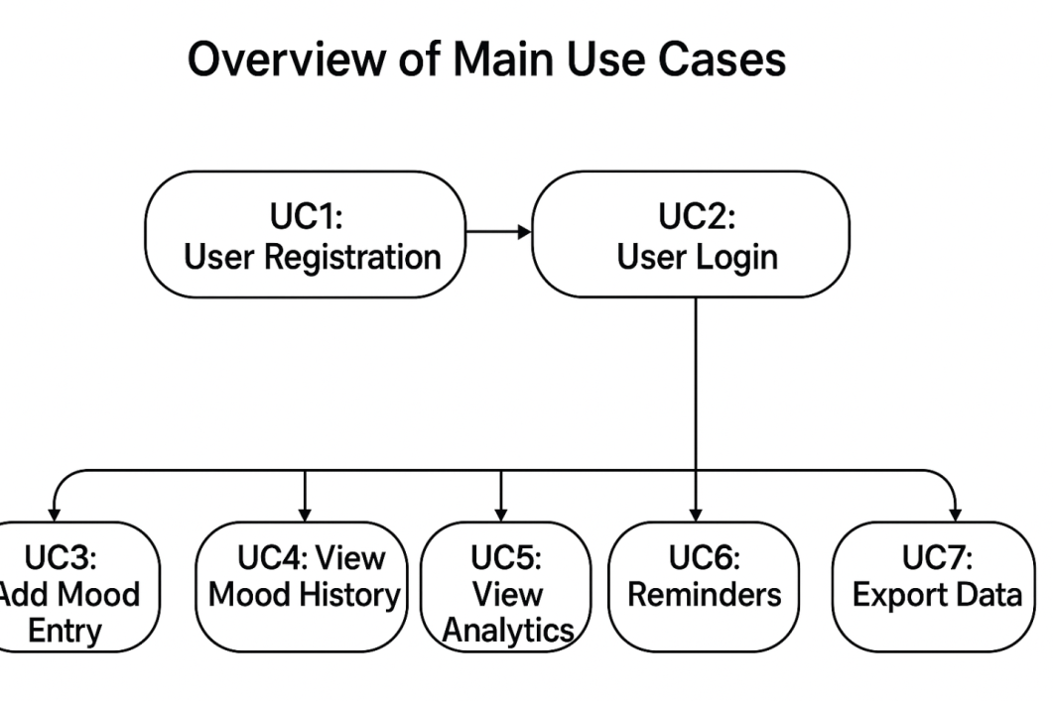

Figure 1: System Level Use Case Diagram

  - Use Case 1
ID | User id
Name | User name
Description | This use case describes the process through which a new user creates an account in the Mental Health Tracker System to access mood tracking, symptom logs, reminders, and analytics features.
Requirement(s) | User Sign Up
Actor(s) | • User (Patient/General User)  • Admin
Precondition | The user must not already have an existing account in the Mental Health Tracker System
Post condition | - A new user account is created.  - User receives a confirmation or an approval notification (if admin approval is required).
Basic Flow | Basic Flow  • User opens the Sign-Up page.  • User enters all required credentials.  2.1. Required fields:  - Name  - Email  - Password  - Address (optional depending on system design)  - Phone Number  • System validates the inputs.  3.1. Validation includes:  - Valid email format  - Password must be at least 8 characters and include a number  - Phone number must contain 11 digits  • If all inputs are valid, the system creates a new user account.  • System displays a success message (and pending approval message for Admin-created accounts).  Alternative Flow  1: Admin Creates a User Account  - Admin logs into the system.  - Admin opens the “Create User” or “Add User” section.  - Admin enters user information manually.  - System validates and creates the new account.  Exceptions  - Invalid Inputs  - Missing required fields  - Invalid email format  - Weak password  - Incorrect phone digit count  → System displays error messages and prevents account creation.  - System Unable to Respond  - Server or database issue  - Network failure  → System shows an error notice and asks user to try again later.
Diagram
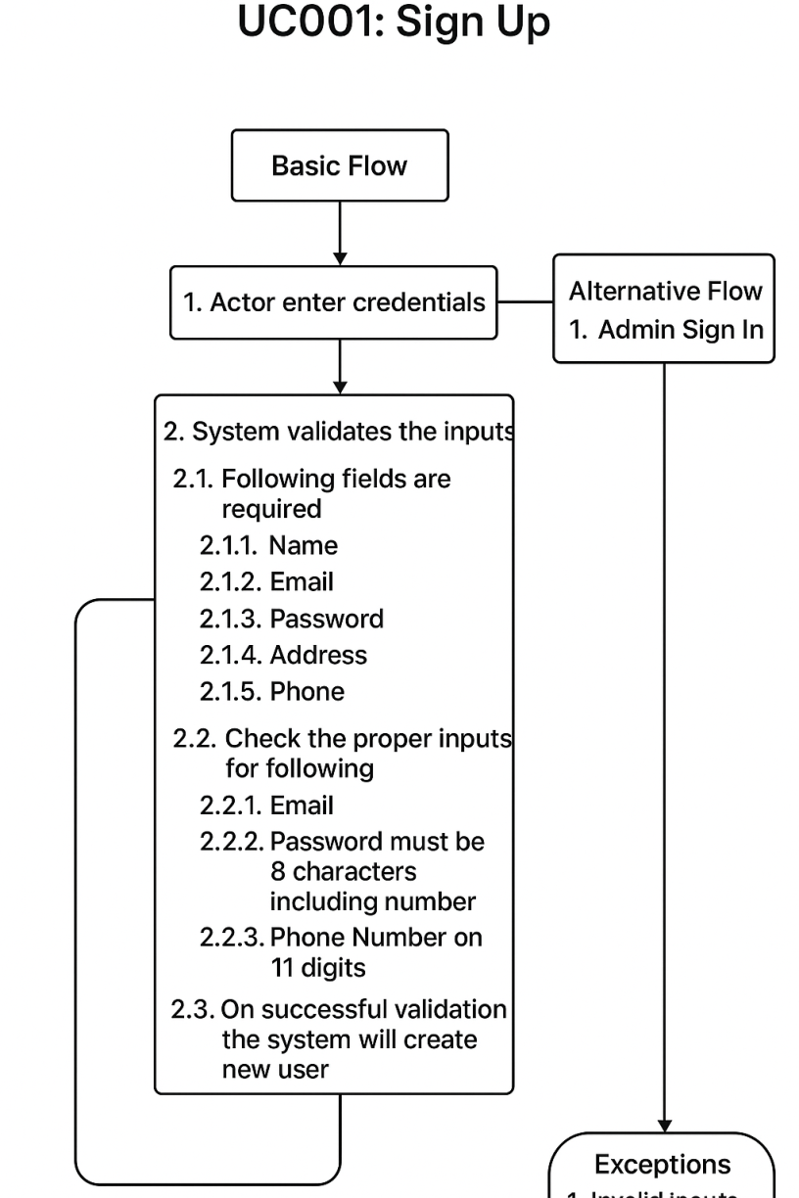

References

1. Research on Mobile Mental Health Apps
- Firth, J., Torous, J., Nicholas, J., Carney, R., Pratap, A., Rosenbaum, S., & Sarris, J. (2017). The efficacy of smartphone-based mental health interventions for depressive symptoms: A meta-analysis of randomized controlled trials. World Psychiatry, 16(3), 287–298.

2. Mood Tracking & Self-Monitoring
- Kauer, S. D., Reid, S. C., Crooke, A. H., Khor, A., Hearps, S., Jorm, A. F., & Patton, G. C. (2012). Self-monitoring using mobile phones in the early stages of adolescent depression: Randomized controlled trial. Journal of Medical Internet Research, 14(3).

3. User Engagement in Health Apps
- Perski, O., Blandford, A., West, R., & Michie, S. (2017). Conceptualising engagement with digital behaviour change interventions: A systematic review using principles from clinical psychology. Journal of Medical Internet Research, 19(5).

4. Digital Mental Health System Design
- Torous, J., & Powell, A. C. (2015). Current research and trends in the use of smartphone applications for mood disorders. Internet Interventions, 2(2), 169–173.

5. Privacy & Security in Health Applications
- Martinez-Martin, N. (2019). What are important ethical implications of using digital tools for mental health? AMA Journal of Ethics, 21(2), E155–E160.

6. WHO Digital Health Guidelines
- World Health Organization. (2020). WHO guidelines on digital health interventions. WHO Press?

7. Medical Informatics & Health Tracking
- Luxton, D. D. (2016). Artificial intelligence in psychological practice: Current and future applications and implications. Professional Psychology: Research and Practice, 47(5), 386–393.

Good General References for Mental Health Apps
These can be used in SRS "Literature Review / Related Work" section.
- Headspace. (2023). Mindfulness & Meditation App.
- Calm. (2023). Mental wellness and sleep app.
- Wysa. (2023). AI-powered mental health support application.

Website / Online Sources
Use these for your project background or SRS perspective:
- National Institute of Mental Health (NIMH) – https://www.nimh.nih.gov
- World Health Organization – Mental Health – https://www.who.int/health-topics/mental-health
- Mental Health America – https://mhanational.org
- Mayo Clinic – Mental Health Self-Assessment Tools

